|  |  |
| --- | --- |
| Can you help us to keep an eye on Ellis?  Ellis is a common or harbour seal and, contrary to their name, common seals are very uncommon around the coast of Cornwall.  Ellis was first seen in October 2009 by Claire Lewis, a warden on Looe Island Nature reserve. It is hard to tell the sex of common seals and Ellis was originally thought to be a female and was named Elisa. Two years later, in 2011, Lucy Tozer saw Elisa on the Roseland peninsula (28 miles west of Looe Island) and Rhian Grey saw Elisa there again in November 2013. Early 2014 saw Elisa back at Looe Island. However, in June 2014, Elisa was seen by Rob Wells on the Roseland where he and Kath Wherry have monitored seals at least weekly ever since. Elisa has subsequently been recorded by Rob and Kath at least 60 times on the Roseland and their photographs confirmed that Elisa is actually a boy, so she was renamed Ellis.  Atlantic grey seals are seen around the Roseland peninsula too and Ellis is often seen near but not amongst them. Grey seals grow larger than common seals with a flatter head shape and larger, bolder markings for females and often very few markings on males.  For the first six years that Ellis was seen, he appeared fine, seen below with the typical dotty/ringed pattern all-over his fur. The following two photographs show a female and a male grey seal for comparison. |  |

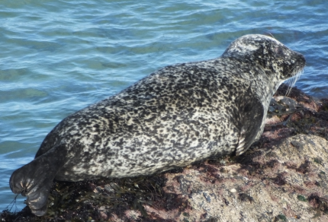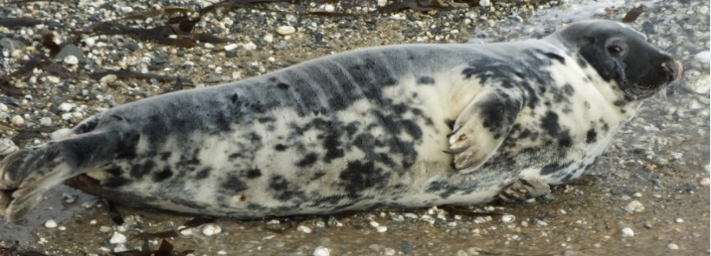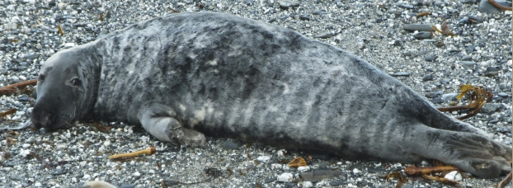

7th Dec 2014. Ellis as we saw him for the first six years :A female (above) Atlantic grey seal and male (below).

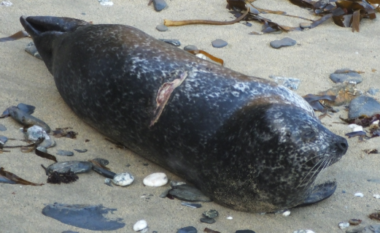However, in February 2016 Ellis was seen to have an injury on his back (shown below). He had a deep cut across his back through his skin and blubber. In other respects he looked and behaved OK and did not appear to be troubled by the injury. No bleeding was seen. Perhaps he had been struck by a boat?

25 Feb 2016. Ellis with a deep wound across his back

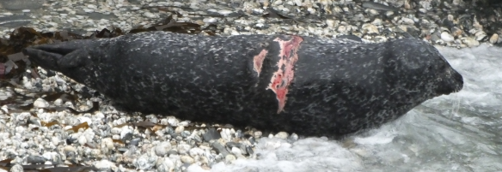Then in December 2016 a large red patch appeared across his back above the original wound. This seemed unlikely to be an additional injury, more likely a large red weal or skin condition with some patches of original skin still showing. Again, Ellis seemed unconcerned, his mobility was normal and he was not seen to try to rub or scratch it. This second mark, like the first, was not seen to bleed.

21 Dec 2016. A large red weal has appeared

Since 2016, the weal and injury have healed a little. Seals have a special adaptation which helps skin injuries to seal up quickly but the final photograph from late January 2019 shows that over two years later, the wounds are still very evident with missing skin and exposed flesh.

The chart below shows that Ellis has been seen in every month of the year but more in the winter than the summer. In fact, his behaviour has changed in that summer sightings have decreased and he was not seen at all from March to July in 2018. He then reappeared and popped into the Fal Estuary for a rest. Where had he been?

Many of our seals go missing, sometimes for years but the red marks on Ellis’ back make him an easy seal to recognise and identify SO WE WOULD LIKE PEOPLE TO LOOK OUT FOR HIM. If you do spot him, please email [sue@cornwallsealgroup.co.uk](mailto:sue@cornwallsealgroup.co.uk) . The more we can learn about our seals, the better we can protect them.

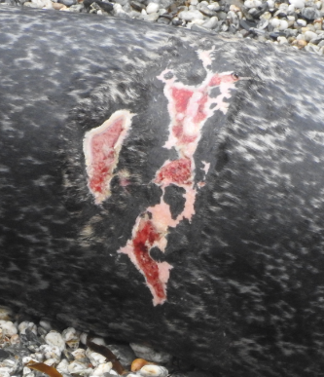Cornwall Seal Group Research Trust calendar of Ellis’ sightings.  
Number and location of identifications per month.

24 Jan 2019

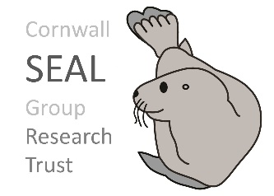

All photos by Rob Wells. Sightings calendar by Sue Sayer

Rob Wells. April 2019.

Please help us to keep an eye on Ellis.